

PROCESSING GUIDE
TUBALL™ MATRIX 822
FOR 30 WT.% GLASS FIBER FILLED
PA-6 AND PA-6.6 COMPOUNDS

Recommended Equipment
Procedure
Quality Control

V01_20220404

INTRODUCTION
To prepare electrically conductive PA-6 and PA-6.6 compounds at 30% glass fibers, TUBALL™ MATRIX 822 (25 wt.% TUBALL™ nanotubes concentrate) should be used.  TUBALL™ MATRIX 822 is available in pellets form to facilitate the incorporation on standard compounding lines.  Uniform distribution of TUBALL™ MATRIX 822 in polyamide plays a key role in enhancing the electrical conductivity of the final compound. | 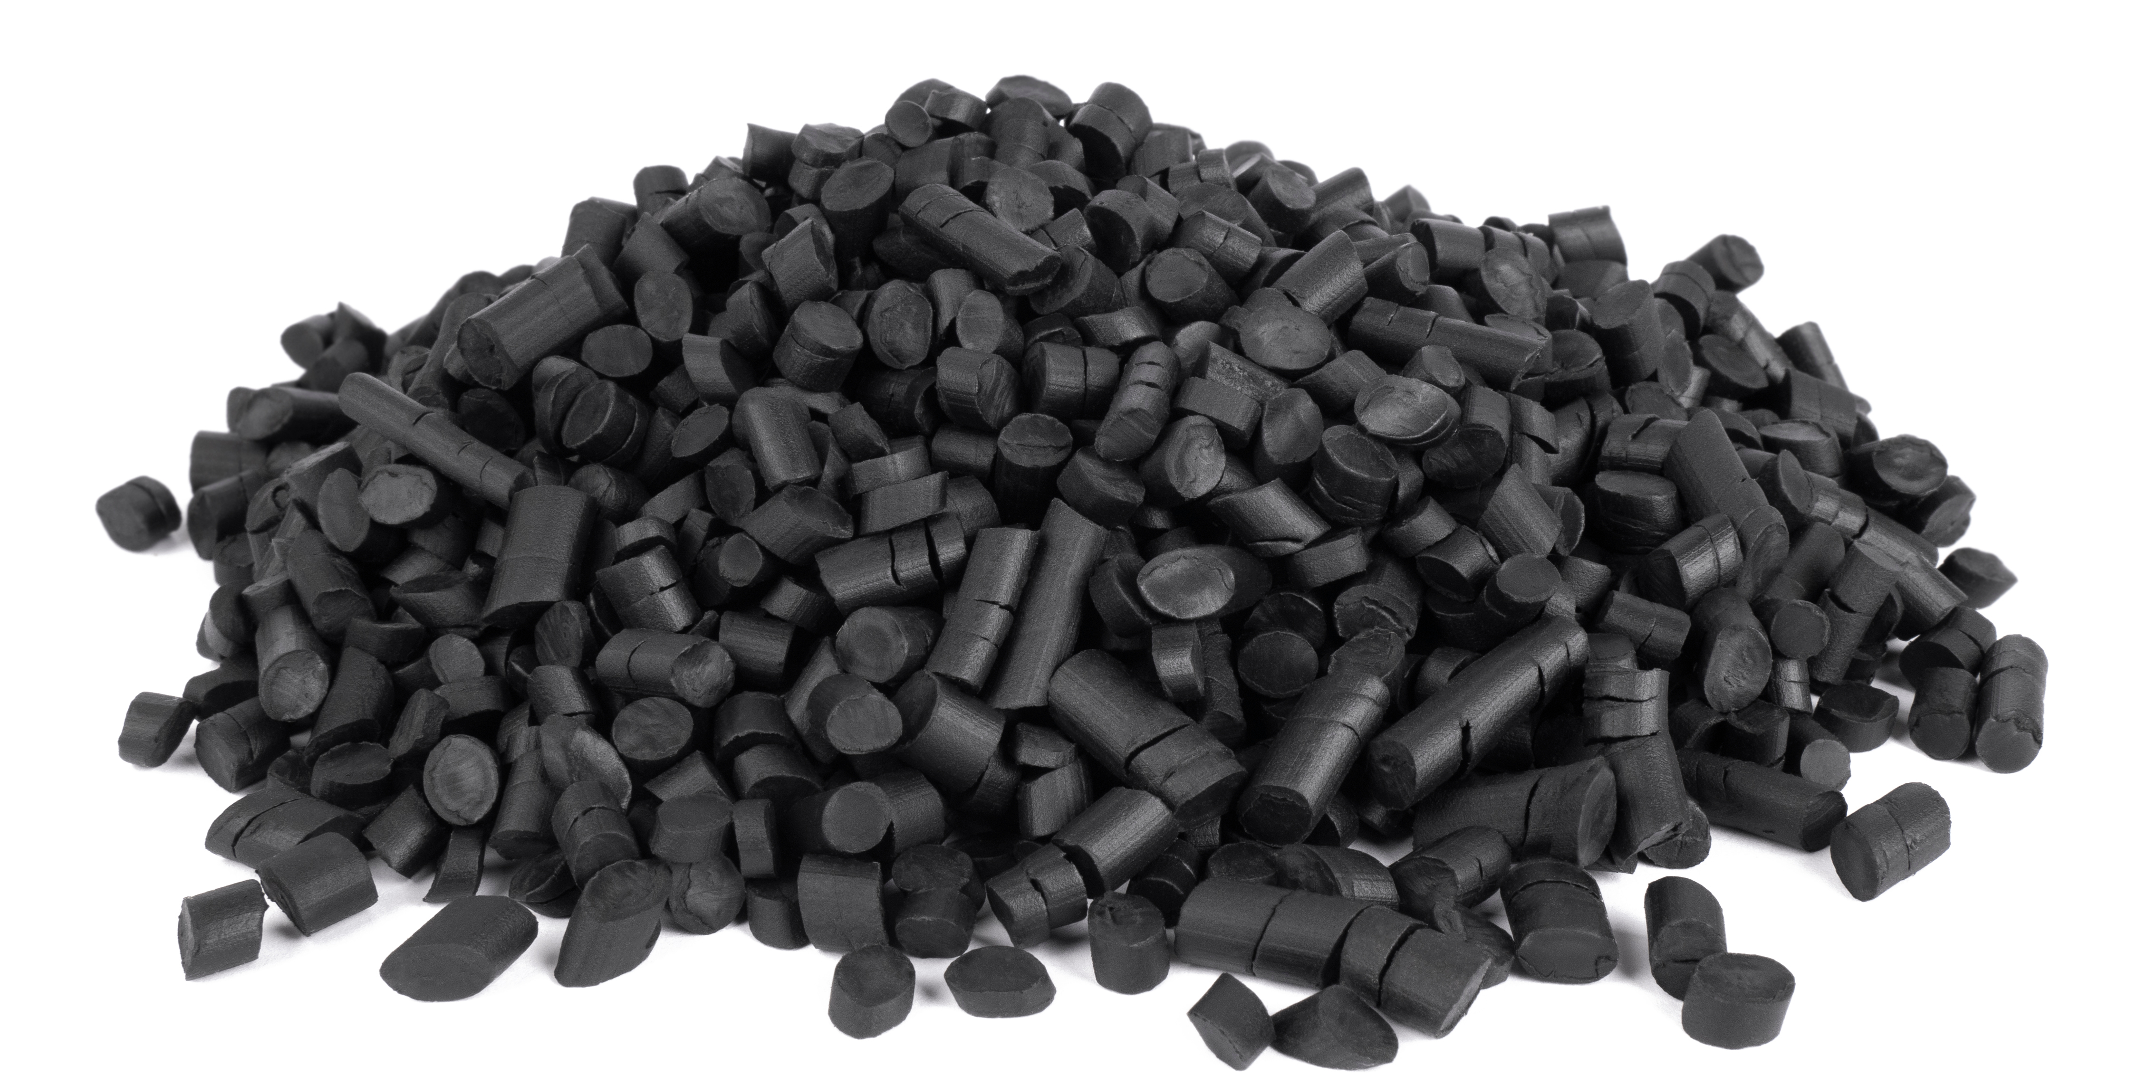  Figure 1. TUBALL™ MATRIX 822 appearance

RECOMMENDED EQUIPMENT
The twin screw that has a length to diameter (L/D) ratio of at least 40.  In the examples of this guide the extrusion parameters have been developed for a Leistritz ZSE27 Maxx 28mm twin screw with L/D:40. | 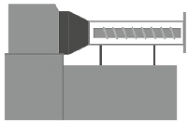

RECOMMENDED COMPOUNDING STEPS
The incorporation of TUBALL™ MATRIX 822 consists of next steps:
- Dilution in neat polymer (PA-6 or PA-6.6) of TUBALL™ MATRIX 822 on twin-screw extruder to a concentrate on of 8/16 wt.% which is equivalent to 2/4 wt.% TUBALL™ nanotubes. This concentrate is called intermediate masterbatch.
- Dilution of the intermediate masterbatch prepared in step 1 on twin-screw extruder to the typical concentration of TUBALL™ nanotubes of 0.1–0.2 wt.% in neat polymer (PA-6 or PA-6.6) and incorporation of the 30 wt.% glass fibers.
- The compounds can be further injection molded under the typical process conditions for the preparation of specimens with required electrical performance and maintained mechanical properties. Other final processing methods can be applied.

PROCEDURE
STEP 1. Intermediate masterbatch preparation
The masterbatch can be produced on a twin-screw extruder by the compounding of the pellets of PA-6 (or PA-6.6) in combination with the concentrate TUBALL™ MATRIX 822. Both materials should be fed though main hopper. The masterbatch prepared in this step can typically contain 2 or 4 wt.% TUBALL™ nanotubes, i.e., 8 or 16 wt.% of TUBALL™ MATRIX 822.
For a first evaluation, it is proposed to consider a dosage of 8 wt.% of TUBALL™ MATRIX 822 (2 wt.% TUBALL™ nanotubes). Depending on polymer grade and equipment envisaged, preparation of masterbatch at high dosages of MATRIX 822 can be more difficult, in this case it is recommended to reduce the dosage of MATRIX 822 in the masterbatch.
The PA-6 (or PA-6.6) should be used in dry state as per respective TDS. As applicable, MATRIX 822 can be dried under vacuum at room temperature.
The twin screw should have a length to diameter (L/D) ratio of at least 40. In the examples hereafter the extrusion parameters have been developed for a Leistritz ZSE27 Maxx 28mm twin screw with L/D:40. A screw speed of 400 rpm combined with an output rate of 10kg/h was considered for both PA-6 and PA-6.6 masterbatches with the respective temperature profiles shown in Table 1.
Table 1. Example of typical temperature profiles for intermediate masterbatch extrusion
Masterbatch base |  | Zone #
Masterbatch base |  | 1 | 2 | 3 | 4 | 5 | 6 | 7 | 8 | 9 | 10
PA-6 | T, ˚C | 50 | 160 | 280 | 270 | 260 | 260 | 260 | 255 | 250 | 250
PA-6.6 | T, ˚C | 50 | 160 | 290 | 285 | 280 | 280 | 275 | 270 | 270 | 270
STEP 2. Dilution quality control of masterbatch
Check the dilution quality of the masterbatch (see “Quality Control” section).
STEP 3. Target dosage determination
Depending on the characteristics of the dilution polymer and the processing conditions, the loading range of masterbatch required for anti-static or dissipative applications can vary. The exact loading level depends on the required performance, system characteristics, processing conditions and presence of other ingredients. Table 2 provides recommended starting dosages of masterbatch prepared in step 1 for evaluation.
If the content of glass fibers in the compound is lower than 30 wt.%, for a given target resistivity, the dosage of conductive masterbatch should be higher than mentioned in table 2.

Table 2. Example of typical masterbatch dosages for the compounding of 30 wt.% glass fiber filled polyamide (GF PA)
Base polymer of compound | Recommended masterbatch | Recommended starting dosage of masterbatch | Expected volume resistivity* | Expected surface resistivity**
PA-6 +  30 wt.% GF | PA-6 at 2 wt.% TUBALL™ nanotubes | 5 wt.% | 10⁴–10⁵ Ω∙cm | 10⁶–10⁸ Ω/sq
PA-6 +  30 wt.% GF | PA-6 at 2 wt.% TUBALL™ nanotubes | 7.5 wt.% | 10³–10⁵ Ω∙cm | 10⁵–10⁷ Ω/sq
PA-6.6 +  30 wt.% GF | PA-6 at 2 wt.% TUBALL™ nanotubes | 5 wt.% | 10⁴–10⁵ Ω∙cm | 10⁶–10⁸ Ω/sq
PA-6.6 +  30 wt.% GF | PA-6 at 2 wt.% TUBALL™ nanotubes | 7.5 wt.% | 10³–10⁵ Ω∙cm | 10⁵–10⁷ Ω/sq
PA-6.6 +  30 wt.% GF | PA-6.6 at 2 wt.% TUBALL™ nanotubes | 5 wt.% | 10⁴–10⁵ Ω∙cm | 10⁶–10⁷ Ω/sq
PA-6.6 +  30 wt.% GF | PA-6.6 at 2 wt.% TUBALL™ nanotubes | 7.5 wt.% | 10³–10⁵ Ω∙cm | 10⁵–10⁷ Ω/sq
* Injection molded samples. ATSM D4456
** Injection molded samples. ASTM D257
STEP 4. Preparation of PA-6 (or PA-6.6) compounds
PA-6 (or PA-6.6) conductive compound containing 30 wt.% glass fiber should be prepared on a twin-screw extruder. The pellets of masterbatch containing the TUBALL™ nanotubes prepared in step 1 and the pellets of PA-6 (or PA-6.6) should be fed though the main hopper. If the masterbatch and the polyamide are dosed on a single dosing unit, they should first be properly premixed in order to ensure homogenous distribution of the nanotubes.
Before compounding, the intermediate masterbatch and the PA-6 (or PA-6.6) pellets should be dried under the conditions typically required for the specific polyamides considered, typically 80°C during 4 hours in de-humidifying or vacuum dryers.
The glass fibers have to be incorporated downstream on the twin screw through a side feeder in order achieve optimal mechanical properties.
For a Leistritz ZSE27 Maxx 40L/D, a screw speed of 400 rpm combined with an output rate of 10kg/h was considered for the preparation of PA-6 and PA-6.6 compounds with the respective temperature profiles shown in Table 3.
Table 3. Example of typical temperature profiles for the compounding of 30 wt.% glass fiber filled polyamide
Base polymer of compound |  | Zone #
Base polymer of compound |  | 1 | 2 | 3 | 4 | 5 | 6 | 7 | 8 | 9 | 10
PA-6 | T, ˚C | 50 | 160 | 250 | 255 | 260 | 260 | 260 | 260 | 260 | 260
PA-6.6 | T, ˚C | 50 | 160 | 290 | 285 | 280 | 280 | 275 | 270 | 270 | 270

STEP 5. Quality control of compound
Recommended quality control of ready-to-use compound is to follow final processing and measure resistivity of final product. Achievement of the target resistance indicates good quality.
STEP 5. Final processing
The PA-6 (or PA-6.6) compounds at 30 wt.% glass fiber prepared in step 4 are typically used for the preparation of anti-static or conductive (ESD) parts by injection molding for various applications including vehicle exterior parts for electrostatic painting. Molded parts with required electrical performance and maintained mechanical properties can be obtained under the typical process conditions for this type of materials, prior to injection molding the compounds should be dried as appropriate for polyamides.
QUALITY CONTROL
The dilution quality of the masterbatch can be evaluated by optical microscopy. To prepare the compound, put a pellet between two glass slides and then compress it at the high temperature. Recommended plate temperature is 240˚C for PA-6 and 280°C for PA-6.6, pressing during 30 seconds at 5kN.
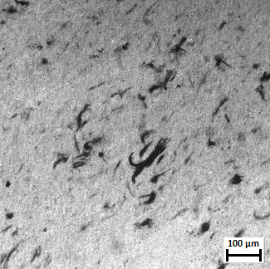
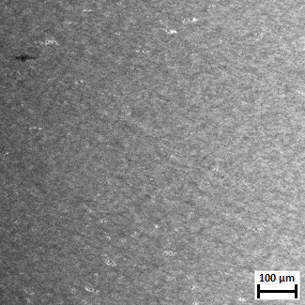
Examples of good and poorly diluted masterbatches at 2 wt.% TUBALL nanotubes can be found in figure 3 and figure 4. While no residual significant black domains of TUBALL™ MATRIX 822 are seen in the well diluted masterbatch, a high number of black agglomerates of undiluted concentrate can be seen when the process conditions are not optimized.
100 μm
100 μm
Figure 3. Optical microscopy – example of good dilution quality of masterbatch | Figure 4. Optical microscopy – example of poor dilution quality of masterbatch

WARRANTIES AND DISCLAIMER
The Products correspond to the chemical composition indicated in the Technical Data Sheet and the Safety Data Sheet supplied with the Product. The information contained in this document (Information) is based on trials carried out by OCSiAl and may contain inaccuracies or errors that could cause injury, loss or damage.
OCSiAl gives no further warranty and makes no further representation regarding the Products and/or the accuracy of Information and/or suggestions for any particular use of the Products or Information, or that suggested use will not infringe any patent. The Products and Information are supplied on an “as is” basis. These express provisions are in place for all warranties, representations, conditions, terms, undertakings and obligations implied by statute, common law, custom, trade usage, course of dealing or otherwise (including implied undertakings of satisfactory quality, conformity with description, fitness for purpose and reasonable skill and care), all of which are hereby excluded to the maximum extent permitted by applicable law.
CONTACT INFORMATION
ASIA |  |  |  | EUROPE | NORTH & SOUTH AMERICA
KOREA  208, Gaetbeol-ro 12,  Yeonsu-gu, Incheon,  21999, Korea  +82 32 260 0407  asiapacific@ocsial.com  HONG KONG  Room 1102, 11/F,  Lippo Sun Plaza, 28,  Canton Road,  Tsim Sha Tsui, Kowloon, Hong Kong  +852 3575 3946 | CHINA  #2004, 20th floor, Tower B, Da Chong Business Centre, Yue Hai Street, Nanshan District, Shenzhen, Guangdong, China  +86 755 867 00059  Ground floor, Unit 4,  Building 7, No.160, Basheng Road, Pudong district, Shanghai, China  +86 135 9012 5295  china@ocsial.com |  | JAPAN  Tokyo, Japan  070-1421-0331  japan@ocsial.com  INDIA  Vimal intertrade PVT Ltd,  Shivam centrium,  Sahar road, Koldongri, Andheri East, Mumbai, 400 069, India  + 91 22 6288 4200  india@ocsial.com | LUXEMBOURG  1 Rue de la Poudrerie,  L-3364, Leudelange,  Grand-Duché de Luxembourg  +352 27990373  europe@ocsial.com | USA  500 S Front St,  Suite 860, Columbus,  OH 43215, USA  +1 415 906 5271 usa@ocsial.com

